ON!Track User Manual
Web Manual Version 1.1

Table of Content
Getting Started 3
What is ON!Track? 3
How does the overall ON!Track process look like? 3
How to add, edit, and delete a location? 7
How to add a new location? 7
How to edit a location? 9
How to delete a location? 12
How to add, edit, and delete a parent location? 15
How to add a new parent location? 15
How to edit a parent location? 18
How to delete a parent location? 20
How to add, edit, delete, retire, and transfer an asset? 22
How to add a new asset? 22
How to add a Hilti asset by using the serial number? 25
How to add multiple assets with mass upload? 29
How to edit an asset? 30
How to change the status of an asset from Operational to Broken, In Repair, Lost or Stolen, or Retired? 33
How to delete an asset? 36
How to transfer an asset to another location? 39
How to find my transferred asset? 49
How to confirm a delivered asset? 51
How to find the transfer history of transferred assets? 54
How to display all my assets at once? 55
How to restock consumables? 56
How to add, edit, and delete an employee? 58
How to add a new employee? 58
How to edit a new employee? 61
How to delete a new employee? 63
How to add, edit, and delete a certificate? 65
How to add a new certificate? 65
How to edit a certificate? 67
How to delete a certificate? 69
How to add, edit, and delete a service? 71
How to add a new service? 71
How to edit a service? 73
How to delete a service? 75
How to add, edit, delete a template as well as assign a certificate or service to it? 77
How to add a new template? 77
How to edit a template? 80
How to delete a template? 82
How to assign a certificate or service to a template? 84
ON!Track in general 87
How to navigate? 87
How to search? 89
How to filter tables? 91
How to sort tables? 92
How to customize tables? 93

Getting Started
The following questions clarify how to get started with ON!Track.

What is ON!Track?
Hilti ON!Track is the professional solution for managing all of your assets, regardless of manufacturer. The software makes it easy to track and search for assets to minimize losses, to maintain inventory lists quickly and easily, all in one place, and to get automated alerts as reminders for repairs, servicing and inspections.

How does the overall ON!Track process look like?
- Once you log in ON!Track, the first view is the dashboard; here you see your locations on the map, your asset status and the asset details below. By clicking on the locations and areas below, respective detailed information are shown.
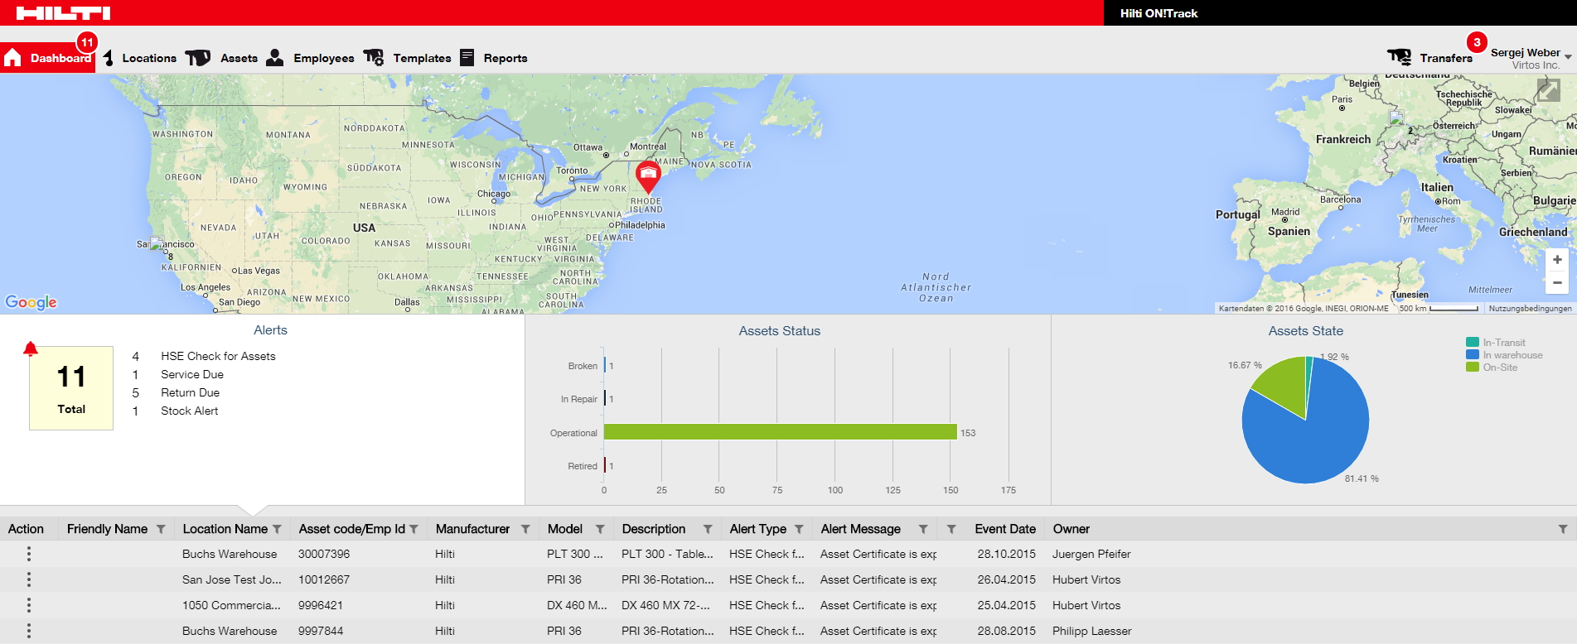

- By clicking on the respective main-navigation points, i.e. dashboard, location, assets, employees, templates, and reports you can retrieve respective information.
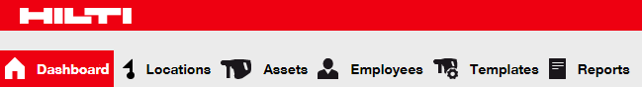

- Under location you manage your (parent) locations; you can add and specify new ones as well as edit and delete existing ones. Here, you can also assign assets to specific locations.
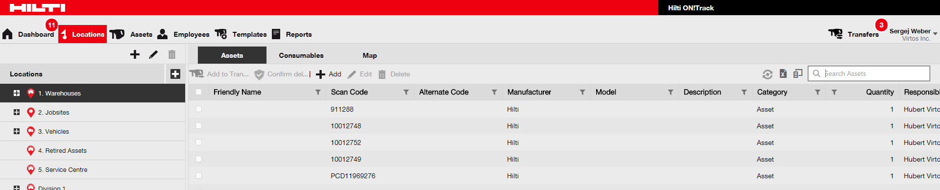

- Under assets you manage your assets, commodities, and consumables; you can add and specify new ones as well as edit and delete existing ones. Here, you can also transfer assets from one location to another or assign certificates to your assets.
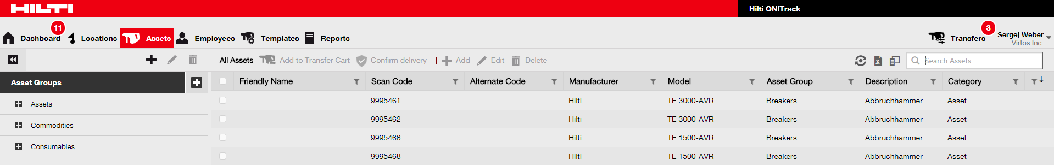

- Under employees you manage your employees (ON!Track users), you can add and specify new ones as well as edit and delete existing ones. Here, you can also assign certificates to employees or define rights management for the other ON!Track users as an administrator.
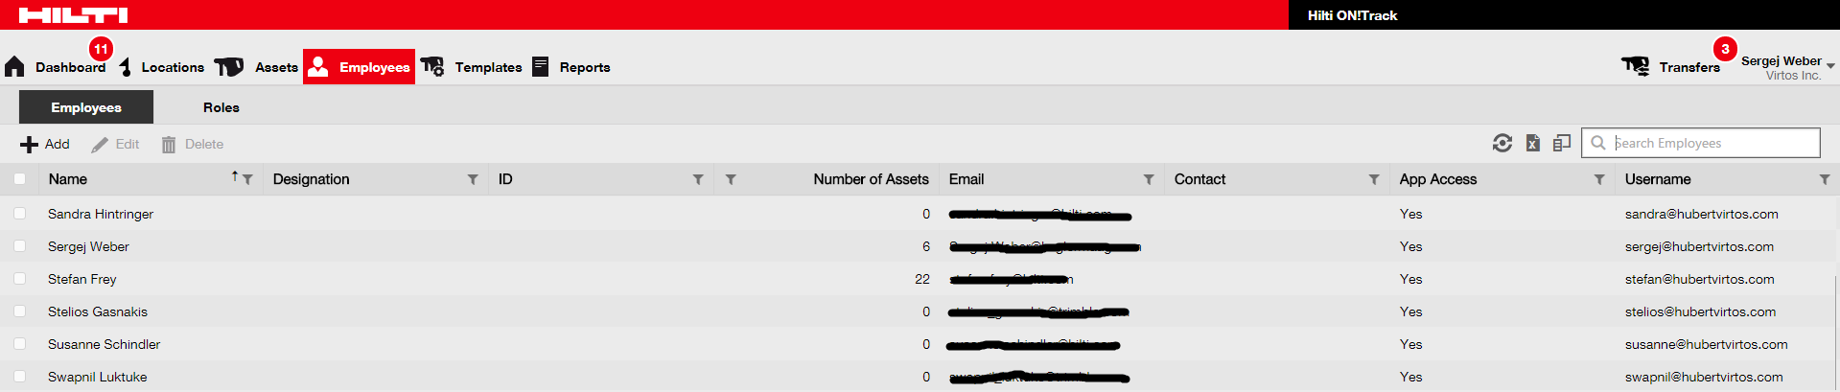

- Under templates you manage your asset templates, certificates for assets and employees as well as services for assets; you can add and specify new ones as well as edit and delete existing ones.
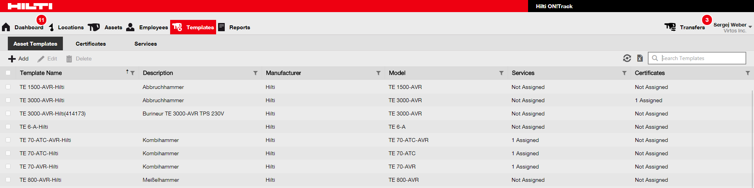

- Under reports you can automatically run reports about your assets, certificates, services, and employees.
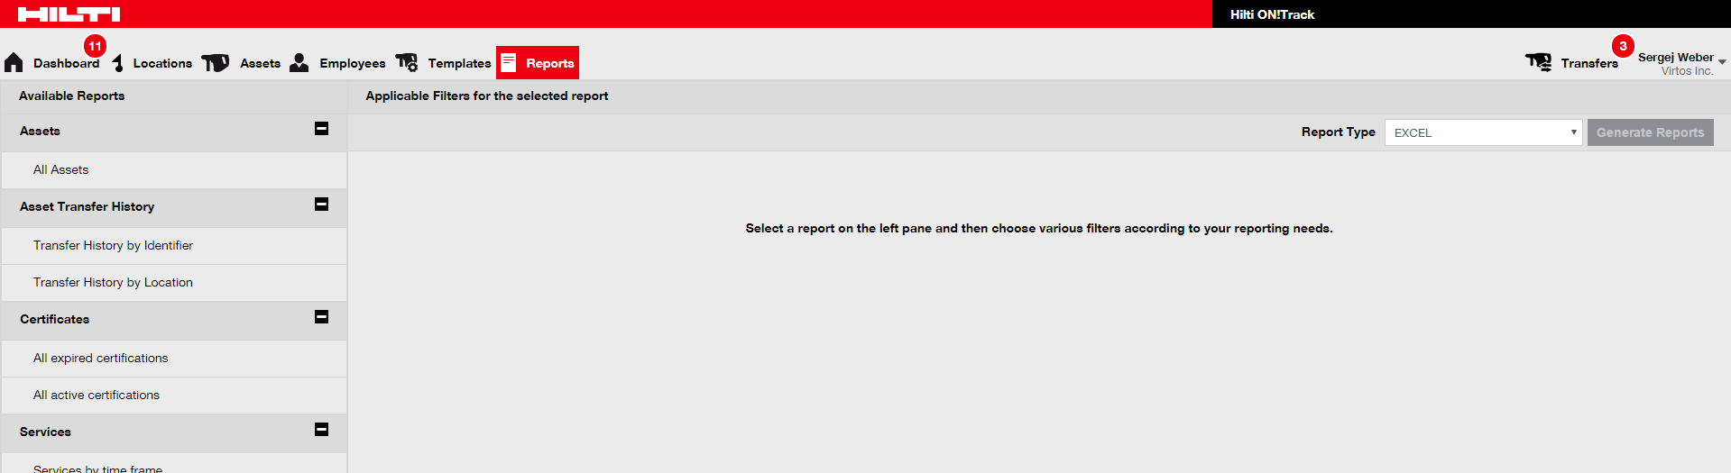

- Under transfers (located on the right-hand screen side) you can automatically create reports about your assets, certificates, services, and employees.
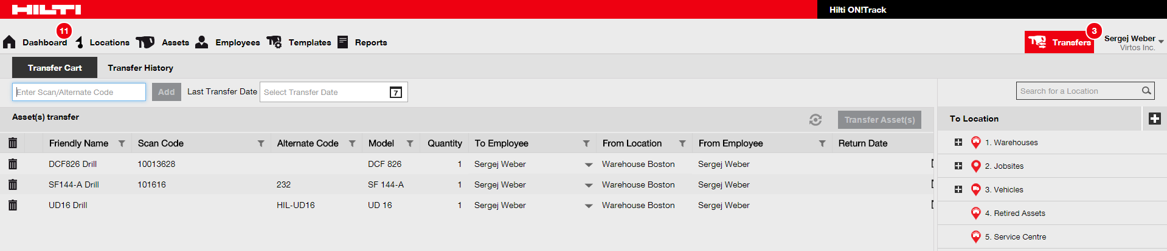

- Under your own login name you can find the company and user settings, the support page and the possibility to logout.
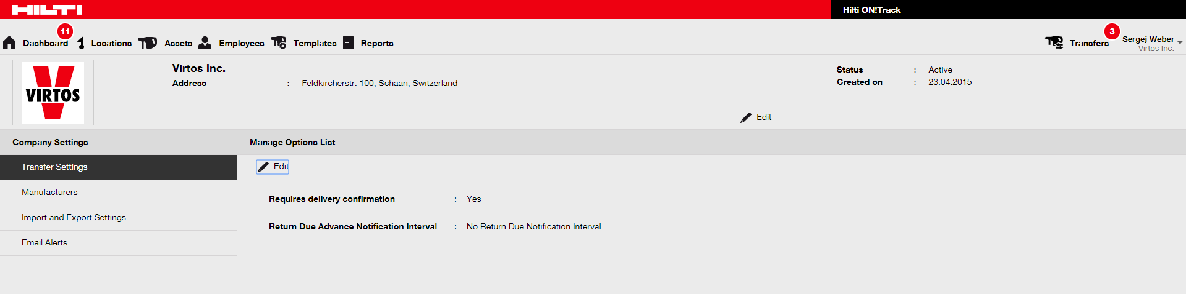

How to add, edit, and delete a location?
Locations specify where your assets are located or to transfer next. These are typically specific warehouses, jobsites, service centers, or vehicles. The following questions will clarify how to add new locations as wells as how to edit and delete existing ones.

How to add a new location?
- Click on locations in the main navigation bar.

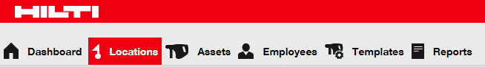

- Click on the plus icon in the sub-navigation bar; a data entry screen opens after clicking on the icon.
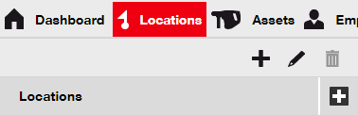

- Choose a parent for the new location by clicking on the respective location (i.e. warehouses, jobsites, etc.)
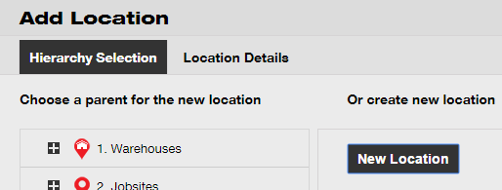

- Click on save and next at bottom of the selection screen to proceed the data entry on the location details tab.

- Fill out the data required on location details tab; mandatory fields are marked red, a complete data entry is advised.
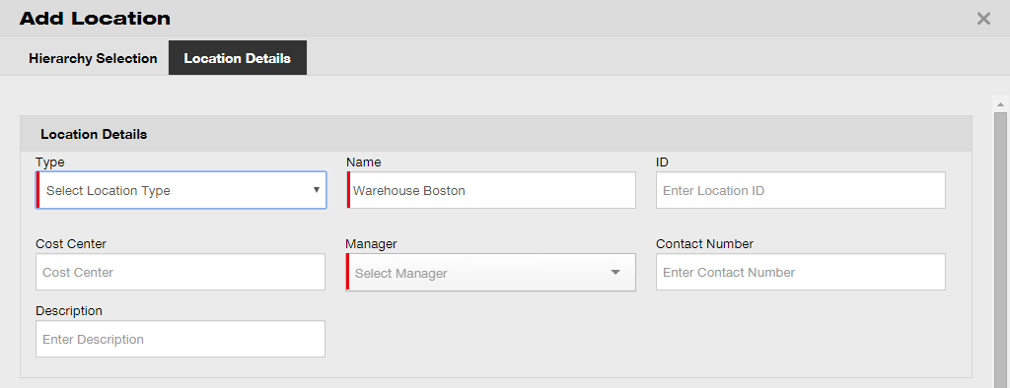

- Click on save and exit at bottom of the data entry screen to complete the addition of a new location.
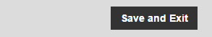

How to edit a location?
- Click on locations in the main navigation bar.

- Click on the plus icon to expand the vertical navigation below.
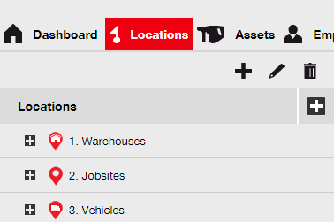

- Click on the location to be edited.
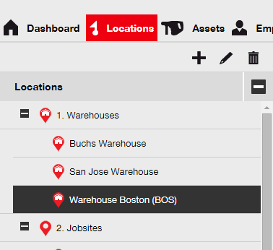

- Click on the pencil icon to edit the selected location; an editing screen with the locations details opens upon clicking on the icon.

- Edit the locations details as required; mandatory fields are marked red, however a complete data entry is advised.
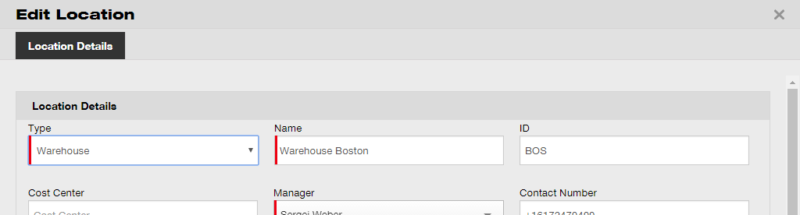

- Click on save and exit at bottom of the editing screen to complete editing the location.

How to delete a location?
Note: Locations with assigned assets cannot be deleted. In order to delete those locations, first remove the asset assignments.

- Click on locations in the main navigation bar.

- Click on the plus icon to expand the locations structure below.

- Select the location to be deleted by clicking on it.

- Click on the trashcan icon to delete the selected location; a confirmation screen opens upon clicking the icon.

- Click on yes to delete the respective location permanently; to cancel the deletion, click on no.

Attention: Once deleted, data cannot be restored!
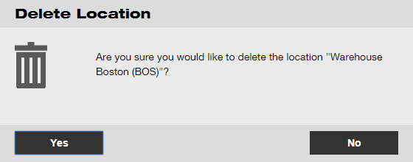

How to add, edit, and delete a parent location?
Parent locations specify location types, i.e. warehouses, jobsites, vehicles, etc. The following questions will clarify how to add new parent locations as well as how to edit and delete existing ones.

How to add a new parent location?
- Click on locations in the main-navigation bar.

- Click on the plus icon in the sub-navigation bar; a data entry screen opens on-click.

- Click on new location; an text field for the location name is displayed.

- Enter a new parent location name in the text field.
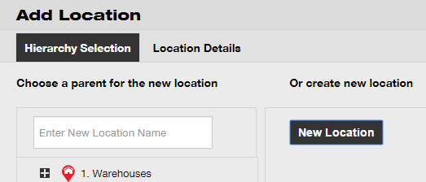

- Click on save and next at bottom of the selection screen to proceed the data entry on the location details tab.

- Fill out the data required on location details tab; mandatory fields are marked red, a complete data entry is advised.

Note: The dropdown “type” contains pre-defined location types, such as container, jobsite, location group, vehicle, and warehouse. Choose a location type that fits best for your location’s purpose.
In order to be able to select a location manager, the person must have been previously defined in ON!Track; you can define a person as such by choosing “location manager” in the responsibility dropdown on the person’s edit page under employees.

- Click on save and exit at bottom of the data entry screen to complete the addition of a new parent location.

How to edit a parent location?
- Click on locations in the main navigation bar.

- Click on the parent location to be edited.

- Click on the pencil icon to edit the selected parent location; an editing screen with the locations details opens upon clicking on the icon.

- Edit the parent locations details as required; mandatory fields are marked red, a complete data entry is advised.
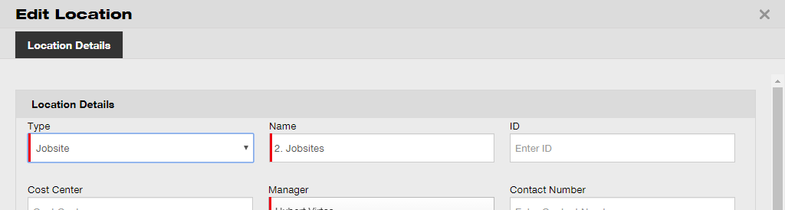

- Click on save and exit at bottom of the editing screen to complete editing the parent location.

How to delete a parent location?
Note: Parent locations with assigned assets cannot be deleted. In order to delete those locations, first remove the asset assignments.

- Click on locations in the main navigation bar.

- Select the parent location to be deleted by clicking on it.

- Click on the trashcan icon to delete the selected parent location; a confirmation screen opens upon clicking the icon.

- Click on yes to delete the respective location permanently; to cancel the deletion, click on no.

Attention: Once deleted, data cannot be restored!

How to add, edit, delete, retire, and transfer an asset?
Asset as a collective term not only includes work tools (like power tools and machines) but also commodities (like gloves or ladders) and consumables (like screws). The following questions clarify how to add new assets as well as how to edit, delete, and transfer existing ones.

How to add a new asset?
Note: Although there are various approaches to add an asset, the simplest manual approach is described here.
- Click on locations in the main navigation bar.

- Click on plus icon (“add”) to add a new asset; a data entry screen opens on-click.
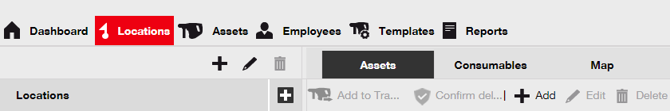

- Fill out the data required on asset details tab; mandatory fields are marked red, a complete data entry is advised. In order to see all mandatory fields, please scroll down in the asset details tab.

Note: scan code refers to the unique code that can be found on the barcode label you equip your asset with. Alternate code is a self-chosen code, which also needs to be unique and must not be assigned twice.
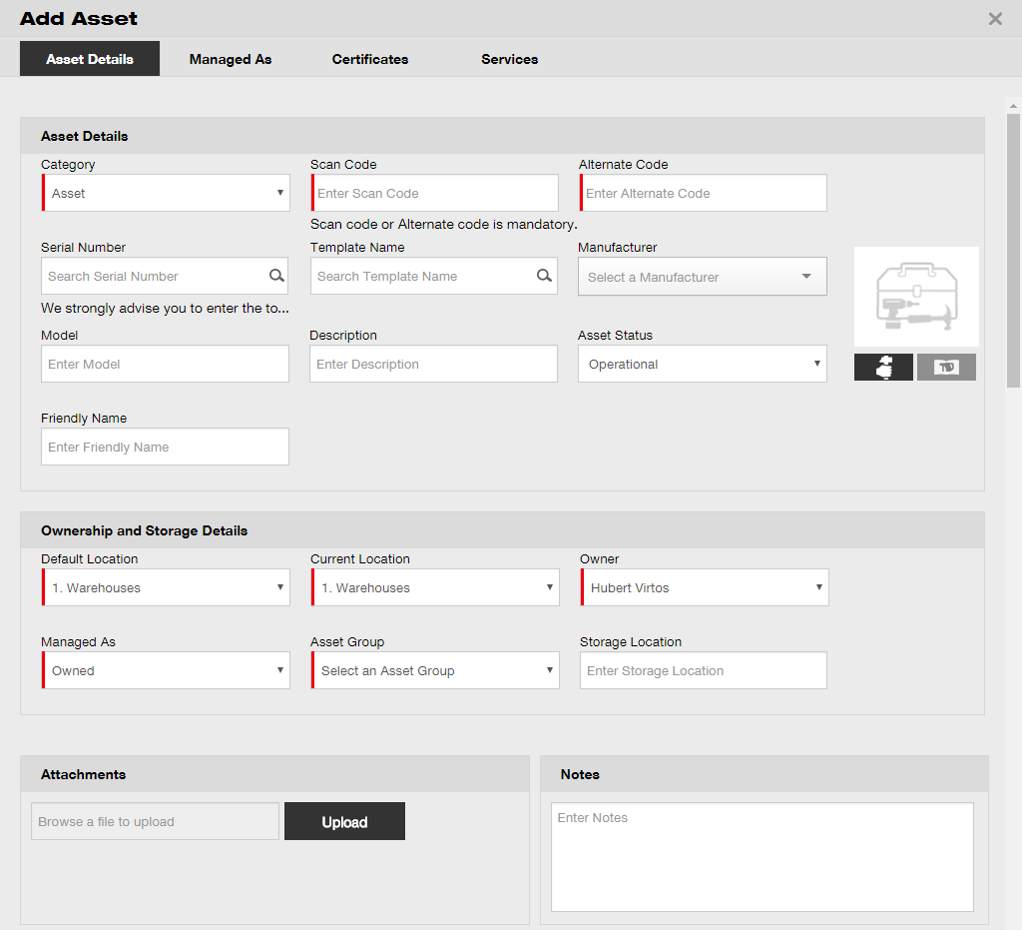

- Click on save and next at bottom of the data screen to proceed the data entry on the managed as tab.

- Fill out the data required on managed as tab; a complete data entry is advised.
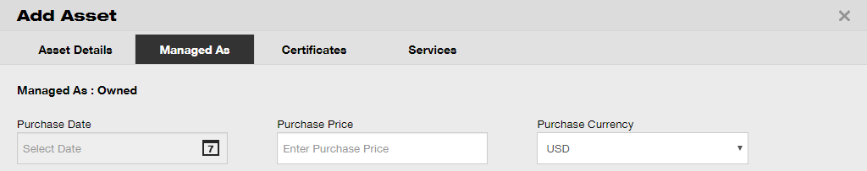

- Click on save and next at bottom of the data screen to proceed the data entry on the certificates tab.

- Select and add certificates required to an asset on certificates tab.

Note: In order to add certificates on this screen, they must have been previously added to ON!Track; you can add certificates under main navigation point templates.
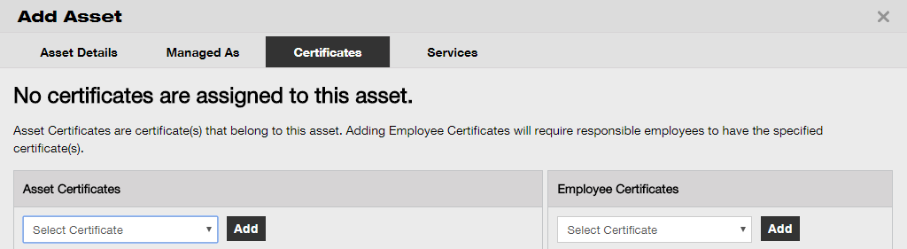

- Click on save and next at bottom of the data screen to proceed the data entry on the services tab.

- Select and add services required to an asset on services tab.

Note: In order to add services on this screen, they must have been previously added to ON!Track; you can add services under main navigation point templates.
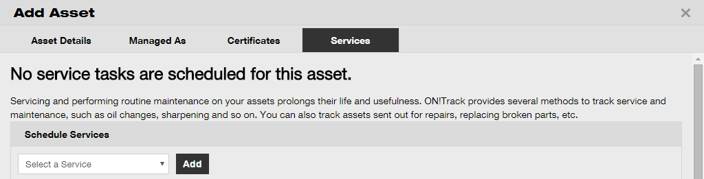

- Click on save and exit at bottom of the data entry screen to complete the addition of a new asset.

How to add a Hilti asset by using the serial number?
- Click on locations in the main-navigation bar.

- Click on plus icon (“add”) to add a new asset; a data entry screen opens upon clicking on the icon.

- Fill out the serial number field with the respective serial number of your Hilti asset on asset details tab.

Note: While typing, the matching serial number will be shown instantly.
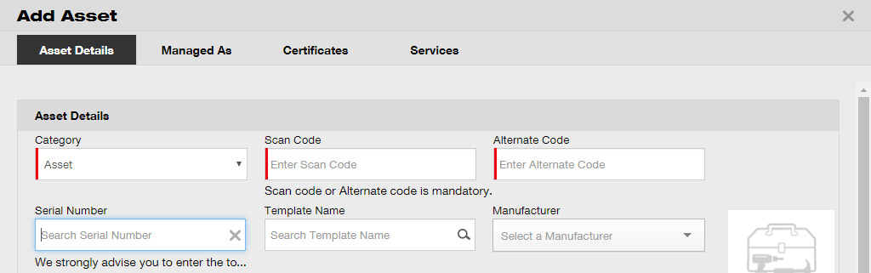

- Select the correct serial number in the dropdown, which is displayed automatically during the typing; on selecting the serial number, selected asset data is pre-filled automatically on the asset details and managed as tab.

Note: Mandatory fields are marked red, a complete data entry, especially e.g. serial number, manufacturer, and model is advised.
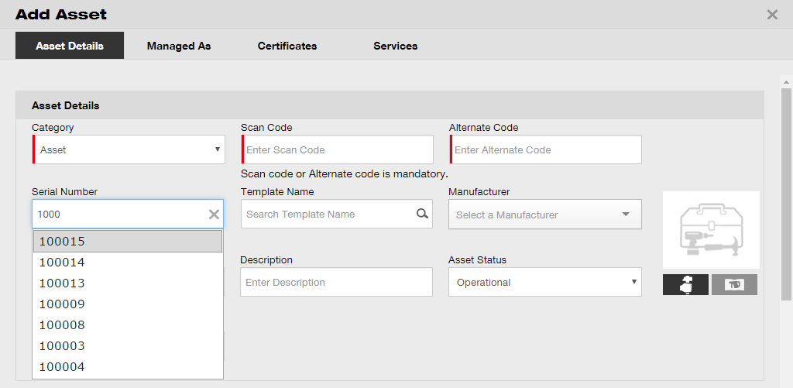

- Click on save and next at bottom of the data screen to proceed the data entry on the managed as tab.

- Fill out the data required on managed as tab; a complete data entry is advised.

- Click on save and next at bottom of the data screen to proceed the data entry on the certificates tab.

- Select and add certificates required to an asset on certificates tab.

Note: In order to add certificates on this screen, they must have been previously added to ON!Track; you can add certificates under main navigation point templates.

- Click on save and next at bottom of the data screen to proceed the data entry on the services tab.

- Select and add services required to an asset on services tab.

Note: In order to add services on this screen, they must have been previously added to ON!Track; you can add services under main navigation point templates.

- Click on save and exit at bottom of the data entry screen to complete the addition of a new asset.

How to add multiple assets with mass upload?
- Select company settings from the drop down menu in the top right corner of the application.
- Select import and export settings. 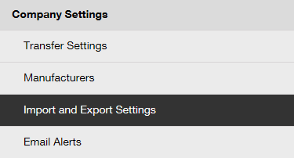
- Select basic asset and click on download.
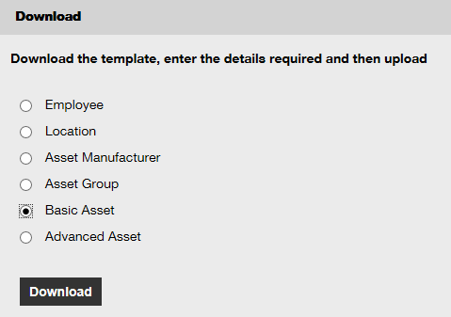
*save the excel template in a convenient location.

- Open the excel template and enter all the information regarding the assets to upload. Columns with the blue header are mandatory fields.
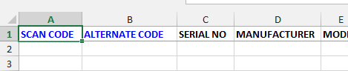

- Before saving and closing the excel template, make sure that all the data is in TEXT format.
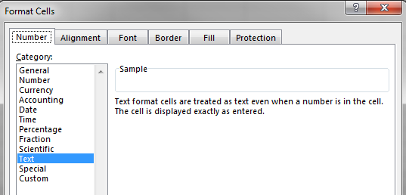

- Before saving and closing the excel template, make sure that all the data is in TEXT format.

How to edit an asset?
- Click on assets in the main navigation bar.

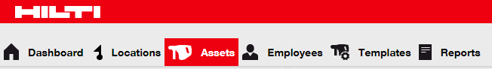

- Click on the plus icon to expand the asset groups structure below.
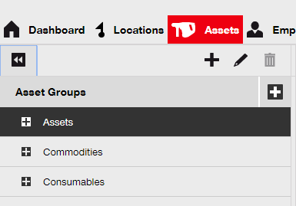

- Select the asset sub-group where the asset to be edited is included.
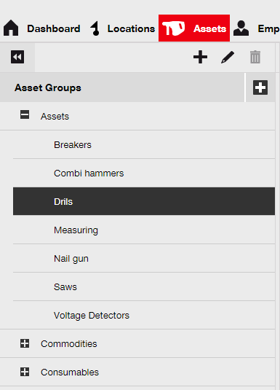

- Select the asset to be edited by ticking the respective checkbox.

Note: Only one asset at a time can be edited.
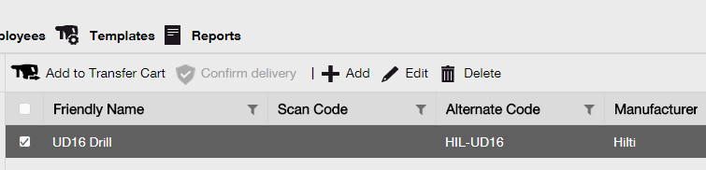

- Click on edit to edit the selected asset; an editing screen with the asset details opens after clicking to edit.

- Navigate to the respective tab (asset details, managed as, etc.) where editing is required and edit data accordingly; mandatory fields are marked red, a complete data entry is advised.
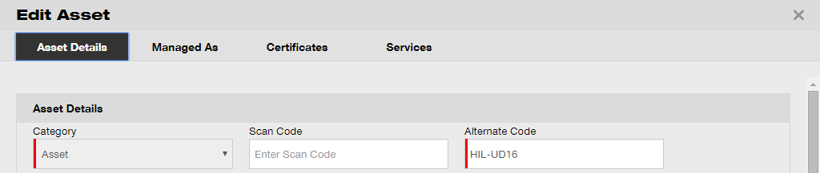

- Click on save and exit at bottom of the editing screen to complete editing the asset.

How to change the status of an asset from Operational to Broken, In Repair, Lost or Stolen, or Retired?
- Click on assets in the main navigation bar.

- Click on the plus icon to expand the asset groups structure below.

- Select the asset sub-group where the asset with the status to be changed is included.

- Select the asset with the status to be changed by ticking the respective checkbox.

Note: Only one asset at a time can be processed.

- Click on edit; an editing screen with the asset details opens on-click.

- On the asset details tab in the asset status dropdown, select the suitable asset status: broken, in repair, lost or stolen, or retired.

Note: Operational is the pre-defined asset status.
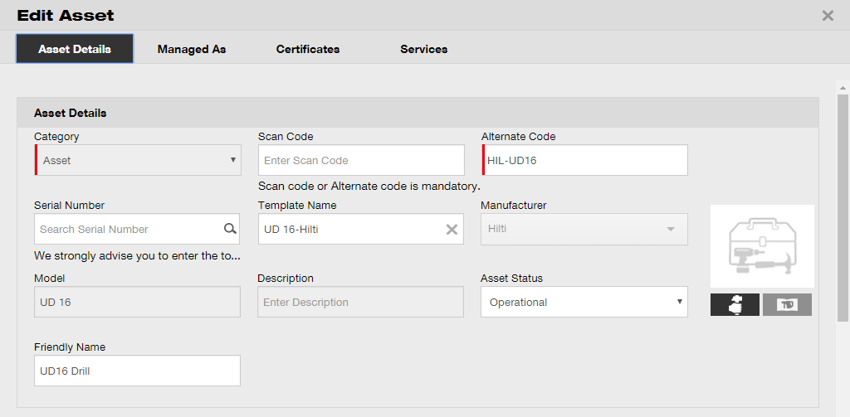

- Click on save and exit at bottom of the editing screen to complete editing the asset.

How to delete an asset?
- Click on assets in the main-navigation bar.

- Click on the plus icon to expand the asset groups structure below.

- Select the asset sub-group where the asset to be deleted is included.

- Select the asset to be deleted by ticking the respective checkbox.

Note: Assets that have been transferred once cannot be deleted but only retired. Furthermore, neither commodities nor consumables can be deleted and/or retired, if the amount is not 0.

- Click on the trashcan icon (“delete”) to delete the selected asset; a confirmation screen opens after clicking.

- Click on yes to delete the respective asset permanently; to cancel the deletion, click on no.

Attention: Once deleted, data cannot be restored!
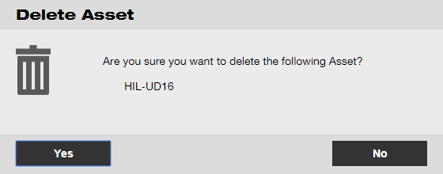

How to transfer an asset to another location?
- Click on assets in the main-navigation bar.

- Click on the plus icon to expand the asset groups structure below.

- Select the asset sub-group where the asset to be transferred is included.

- Select the asset to be transferred by ticking the respective checkbox.
Tip: Select more than one asset to bulk-process items to be transferred. All added assets that are in the transfer cart will be transferred to the same location. If you want to transfer the assets to different locations, repeat the process per location.

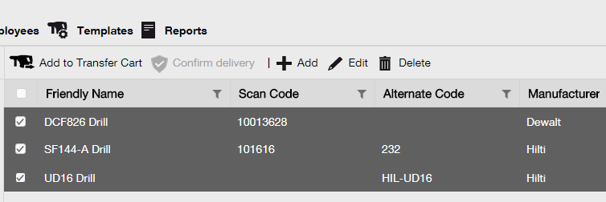

- Click on add to transfer cart to place the selected asset into the transfer cart.

- After placing the asset into the transfer cart successfully, click on transfers in the main navigation bar.
Note: The number within the red circle indicates the number of placed assets in the transfer cart.

- Click on the plus icon to expand the locations structure below.
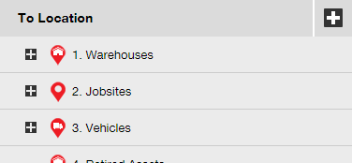

- Select the location where the asset(s) has to be transferred to.
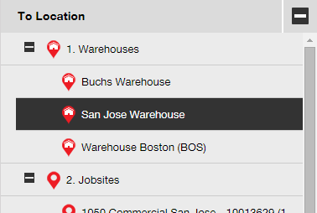

- Click on the calendar icon to pick a date where the asset(s) has to be returned.

Note: return date is an optional entry.
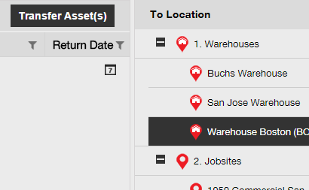

- Select a return date by picking a date in the date picker.
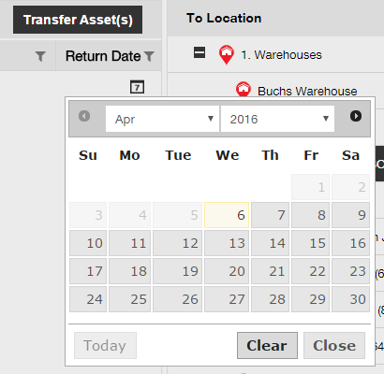

- Click on transfer asset(s) to transfer the asset(s) to the selected location; a confirmation screen opens on-click.
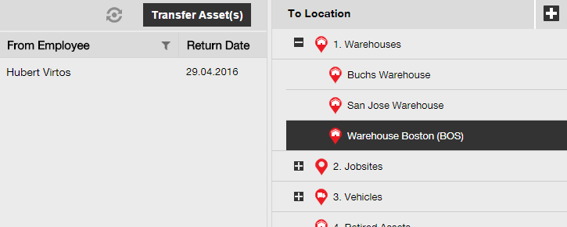

- Click on confirm to transfer the asset to the selected location; to cancel the transfer, click on cancel.

Note: All assets that are in the transfer cart will be transferred to the same location. If you want to transfer the assets in different locations, repeat the process per location.
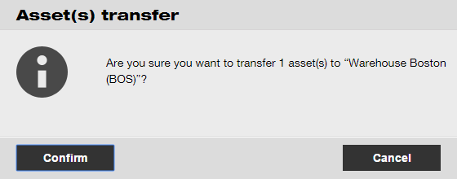

Alternative way to transfer an asset to another location:

- Click on transfers in the main-navigation bar.

- Enter scan/alternate code of the asset to be transferred.
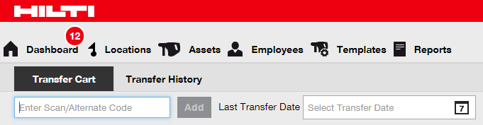

- Click on add to include the respective asset to the transfer cart.

Note: Assets that are already in the transit state meaning the transfer is not confirmed yet cannot be added to the transfer cart.
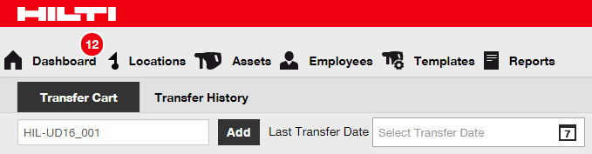

- Click on the plus icon to expand the locations structure below.

- Select the location where the asset(s) has to be transferred to.

- Click on the calendar icon to pick a date where the asset(s) has to be returned.

Note: return date is an optional entry.

- Select a return date by picking a date in the date picker.

- Click on transfer asset(s) to transfer the asset(s) to the selected location; a confirmation screen opens after clicking.

- Click on confirm to transfer the asset to the selected location; to cancel the transfer, click on cancel.

Note: All assets that are in the transfer cart will be transferred to the same location. If you want to transfer the assets in different locations, repeat the process per location.

How to find my transferred asset?
Note: Although there are various approaches to find a transferred asset, here, the simplest approach is described.

- Click on assets in the main navigation bar.

- Click on asset groups to display an overview of all your assets.

- Click into the search field to search for the transferred asset.
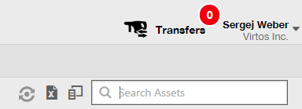

- Type in the search field an information about the asset, e.g. scan or alternate code in order to find it in the list; while typing, the matching information (marked red) will be shown instantly.

Note: Information, which does not match with the search term is blinded out automatically; to see all information (e.g. all assets in the list), delete the search term from the search field by clicking on the x-icon on the right-hand side of the Search field.
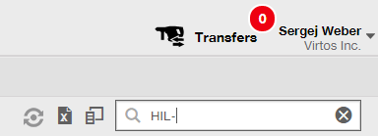
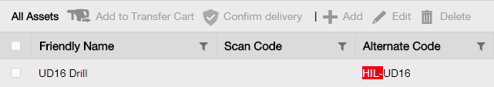

How to confirm a delivered asset?
- After an asset has been delivered, click on assets in the main-navigation bar.

Note: In order to use the delivery confirmations properly, this functionality needs to be turned on beforehand.

- Click on asset groups to display an overview of all your assets.

- Click into the Search field to search for the transferred asset.

- Type in the search field an information about the asset, e.g. scan or alternate code in order to find it in the list; while typing, the matching information (marked red) will be shown instantly.

Note: Information, which does not match with the search term is blinded out automatically; to see all information (e.g. all assets in the list), delete the search term from the search field by clicking on the x-icon on the right-hand side of the search field.

- Select the asset which needs a confirmation of delivery by ticking the respective checkbox.
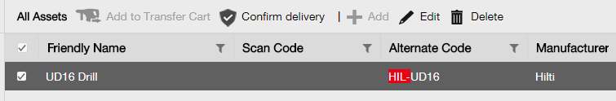

- Click on confirm delivery; a confirmation screen opens after clicking.

- Click on confirm delivery of asset to validate the receipt of the asset; to cancel the confirmation, click on no.
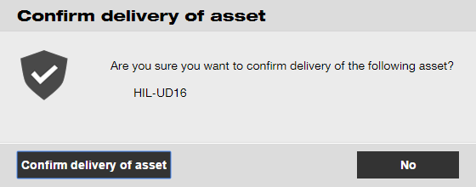

How to find the transfer history of transferred assets?
- Click on transfers in the main navigation bar.

- Click on transfer history tab to see all transfer entries.
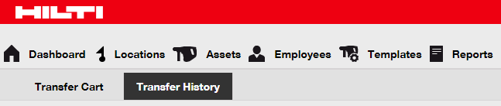

How to display all my assets at once?
- Click on assets in the main navigation bar.

- Click on asset groups; a table on the right-hand side shows all your assets in one big list.

How to restock consumables?
- Click on locations in the main navigation bar.

- Select the consumables tab in the sub-navigation bar.
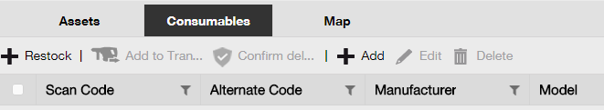

- Click on the plus icon (“restock”); a data entry screen opens after clicking.

- Fill in the scan number of the respective consumables and click on add.
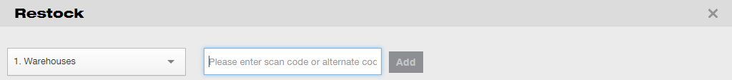

- Fill out the data required; mandatory fields are marked red, a complete data entry is advised.
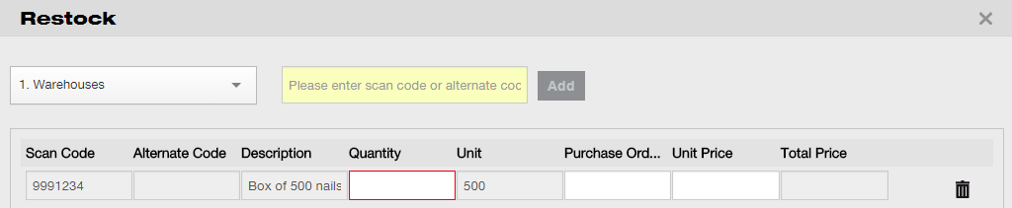

- Click on save at bottom of the data entry screen to confirm the restock of the respective consumable.

How to add, edit, and delete an employee?
Employees are the users of given assets. The following questions clarify how to add new employees as well as how to edit and delete existing ones.
Note: Your possible actions in ON!Track are defined by the authorization model. If you need changes regarding this, please contact your local administrator.

How to add a new employee?
- Click on employees in the main navigation bar.

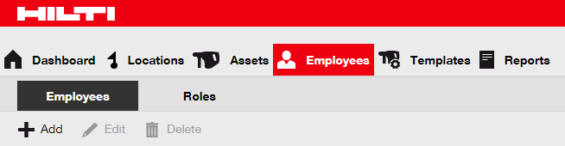

- Click on the plus icon (“add”) to add a new employee; a data entry screen opens after clicking.

- Fill out the data required on Employee Info tab; mandatory fields are marked red, a complete data entry is advised.
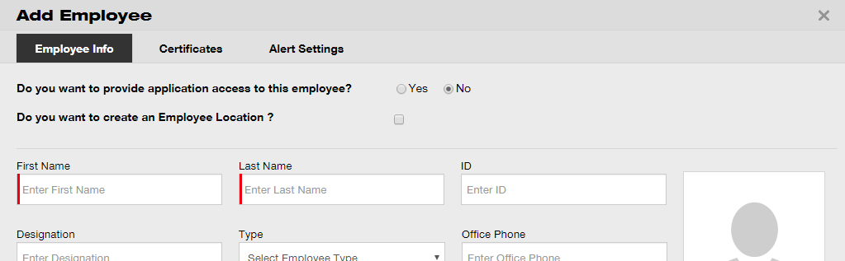

- Click on Save and Next at bottom of the data screen to proceed the data entry on the Certificates tab.

- Select and add Certificates required to an employee on Certificates tab.

Note: In order to add Certificates on this screen, they must have been previously added to ON!Track; you can add Certificates under main navigation point Templates.

- Click on Save and Next at bottom of the data screen to proceed the data entry on the Alert Settings tab.

- Select email alerts for the employee by ticking the respective checkboxes on alert settings tab.

Note: Following email allerts are available: fleet due, HSE check for assets, HSE check for employee, rental due, return due, service due, stock alert, and warranty expiration.

If the checkboxes are grayed-out it means that currently, email alerts are turned off. To enable delivery of alerts via email, please contact your local administrator.
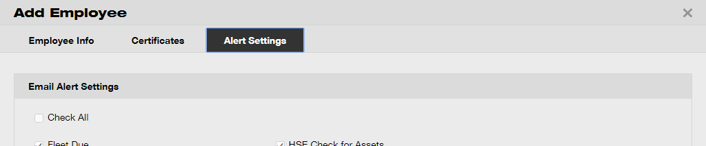

- Click on save and exit at bottom of the data entry screen to complete the addition of a new employee.

How to edit a new employee?
- Click on employees in the main navigation bar.

- Select the employee to be edited by ticking the respective checkbox.
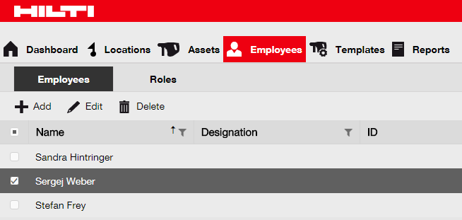

- Click on the pencil icon (“edit”) to edit the selected employee; an editing screen with the employee details opens after clicking.

- Navigate to the respective tab (employee info, assign roles, etc.) where editing is required and edit data accordingly; mandatory fields are marked red, a complete data entry is advised.
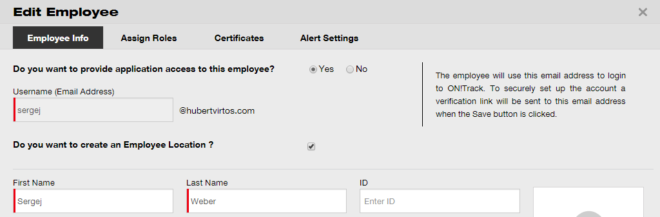

- Click on save and exit at bottom of the editing screen to complete editing the employee.

How to delete a new employee?
- Click on employees in the main navigation bar.

- Select the employee to be deleted by ticking the respective checkbox.

- Click on the trashcan icon (“delete”) to delete the selected employee; a confirmation screen opens after clicking.

- Click on OK to delete the respective employee permanently; to cancel the deletion, click on cancel.

Attention: Once deleted, data cannot be restored!
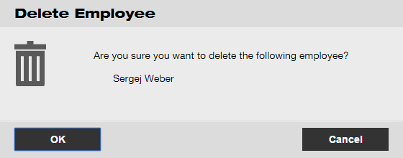

How to add, edit, and delete a certificate?
Certificates are evidences that assets may be used for a specific task or that employees are able and allowed to perform specific work. The following questions clarify how to add new certificates as well as how to edit and delete existing ones.

How to add a new certificate?
- Click on templates in the main navigation bar.

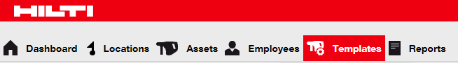

- Select the certificates tab in the sub-navigation bar.
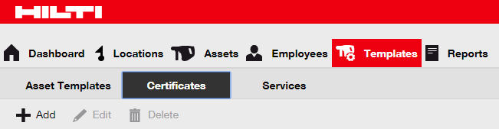

- Click on the plus icon (“add”) to add a new certificate; a data entry screen opens after clicking.

- Fill out the data required; mandatory fields are marked red, a complete data entry is advised.
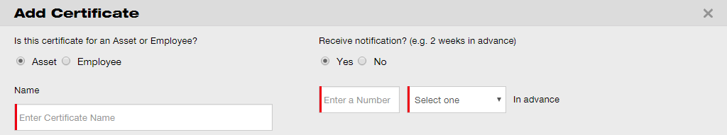

- Click on add at bottom of the data entry screen to complete the addition of a new certificate.

How to edit a certificate?
- Click on templates in the main navigation bar.

- Select the certificates tab in the sub-navigation bar.

- Select the certificate to be edited by ticking the respective checkbox.
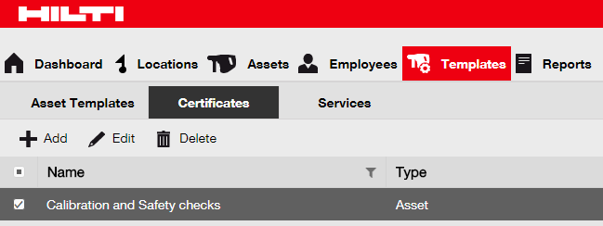

- Click on the pencil icon (“edit”) to edit the selected certificate; an editing screen with the certificate details opens after clicking.

- Edit certificate data accordingly; mandatory fields are marked red; a complete data entry is advised.
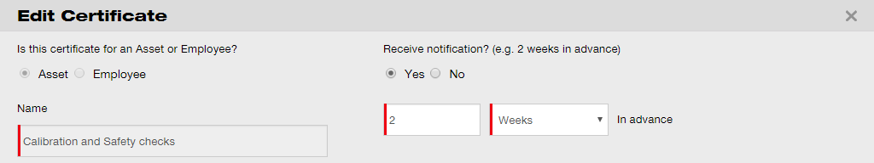

- Click on save at bottom of the editing screen to complete editing the certificate.

How to delete a certificate?
Note: Certificates assigned to employees and/or assets cannot be deleted. In order to delete those certificates, first remove the assignments.

- Click on templates in the main navigation bar.

- Select the certificates tab in the sub-navigation bar.

- Select the certificate to be deleted by ticking the respective checkbox.

- Click on the trashcan icon (“delete”) to delete the selected certificate; a confirmation screen opens after clicking.

- Click on yes to delete the respective certificate permanently; to cancel the deletion, click on no.

Attention: Once deleted, data cannot be restored!
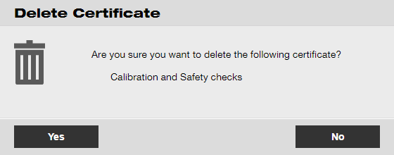

How to add, edit, and delete a service?
Services are maintenance tasks, which need to be performed – often on regular basis – in order to ensure operability of assets. The following questions clarify how to add new services as well as how to edit and delete existing ones.

How to add a new service?
- Click on templates in the main navigation bar.

- Select the services tab in the sub-navigation bar.
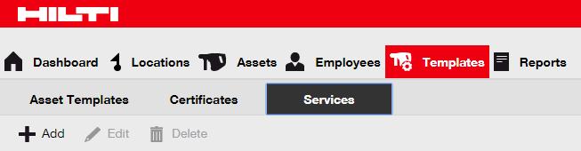

- Click on the plus icon (“add”) to add a new service; a data entry screen opens after clicking.

- Fill out the data required; mandatory fields are marked red, a complete data entry is advised.
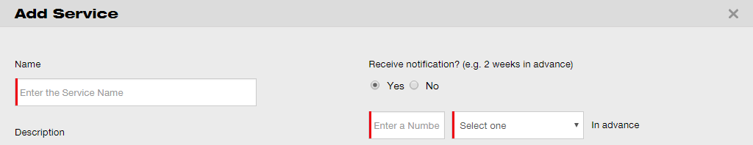

- Click on add at bottom of the data entry screen to complete the addition of a new certificate.

How to edit a service?
- Click on templates in the main navigation bar.

- Select the services tab in the sub-navigation bar.

- Select the service to be edited by ticking the respective checkbox.
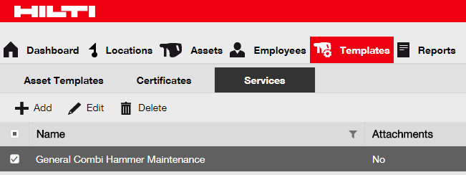

- Click on the pencil icon (“edit”) to edit the selected service; an editing screen with the service details opens after clicking.

- Edit service data accordingly; mandatory fields are marked red; a complete data entry is advised.
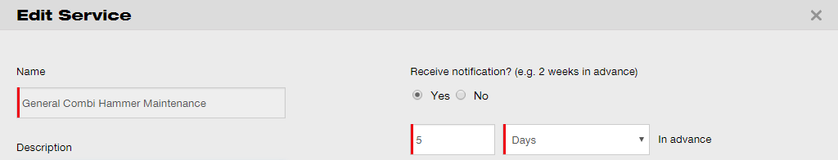

- Click on save at bottom of the editing screen to complete editing the service.

How to delete a service?
Note: Services assigned to assets cannot be deleted. In order to delete those services, first remove the asset assignments.

- Click on templates in the main navigation bar.

- Select the services tab in the sub-navigation bar.

- Select the service to be deleted by ticking the respective checkbox.

- Click on the trashcan icon (“delete”) to delete the selected service; a confirmation screen opens after clicking.

- Click on yes to delete the respective service permanently; to cancel the deletion, click on no.

Attention: Once deleted, data cannot be restored!
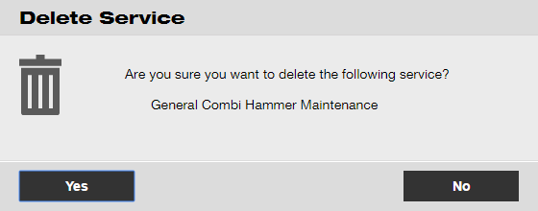

How to add, edit, delete a template as well as assign a certificate or service to it?
A template is a pre-designed set of information, which describes an asset type of and allows maintaining and entering data of additional assets with the same characteristics efficiently. The following questions clarify how to add new templates, how to edit and delete existing ones, and how to assign services and certificates to templates.

How to add a new template?
- Click on templates in the main navigation bar.

- Click on the plus icon (“add”) to add a new template; a data entry screen opens after clicking.
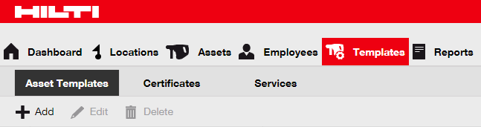

- Fill out the data required on asset template details tab; mandatory fields are marked red, a complete data entry is advised.
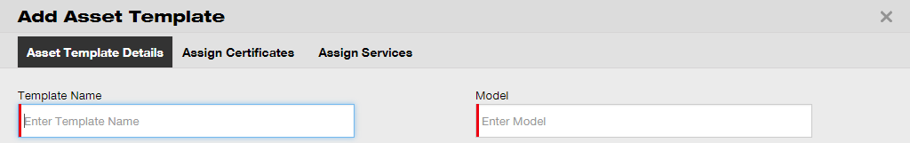

- Click on save and next at bottom of the data screen to proceed the data entry on the assign certificates tab.

- Select and add certificates required to the template on assign certificates tab.

Note: In order to add certificates on this screen, they must have been previously added to ON!Track; you can add certificates on the certificates tab under main navigation point templates.
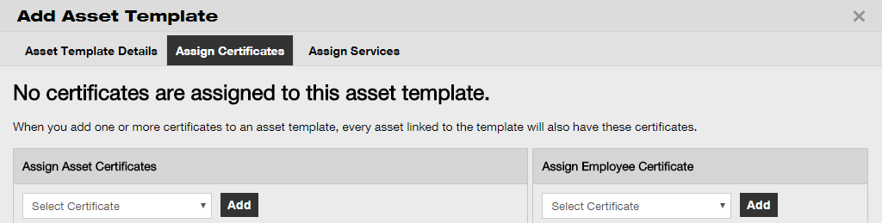

- Click on save and next at bottom of the data screen to proceed the data entry on the assign services tab.

- Select and add services required to the template on assign services tab.

Note: In order to add services on this screen, they must have been previously added to ON!Track; you can add services on the services tab under main navigation point templates.
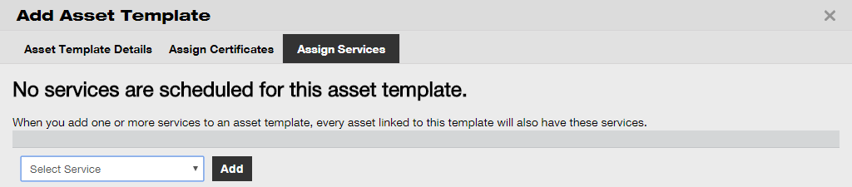

- Click on save and exit at bottom of the data entry screen to complete the addition of a new template.

How to edit a template?
Note: Once created, template names cannot be edited.

- Click on templates in the main navigation bar.

- Select the template to be edited by ticking the respective checkbox.
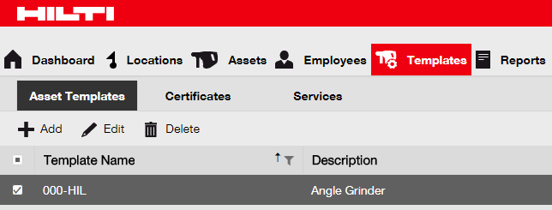

- Click on edit to edit the selected template; an editing screen with the template details opens after clicking.

- Navigate to the respective tab (i.e. asset template details, assign certificates, assign services) where editing is required and edit data accordingly; mandatory fields are marked red, a complete data entry is advised.
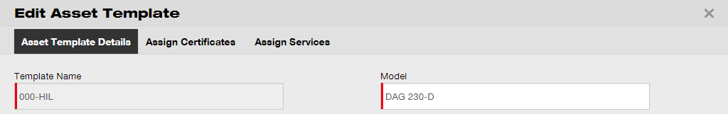

- Click on save and exit at bottom of the editing screen to complete editing the asset.

How to delete a template?
Note: Templates assigned to assets cannot be deleted. In order to delete those templates, first remove the asset assignments.

- Click on templates in the main navigation bar.

- Select the template to be deleted by ticking the respective checkbox.

- Click on the trashcan icon (“delete”) to delete the selected template; a confirmation screen opens after clicking.

- Click on yes to delete the respective template permanently; to cancel the deletion, click on no.

Attention: Once deleted, data cannot be restored!
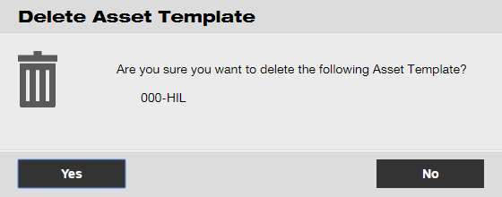

How to assign a certificate or service to a template?
- Click on templates in the main navigation bar.

- Select the template by ticking the respective checkbox.

- Click on edit; an editing screen with the template details opens after clicking.

- Click on the assign certificates tab to assign asset/employee certificates to the template.
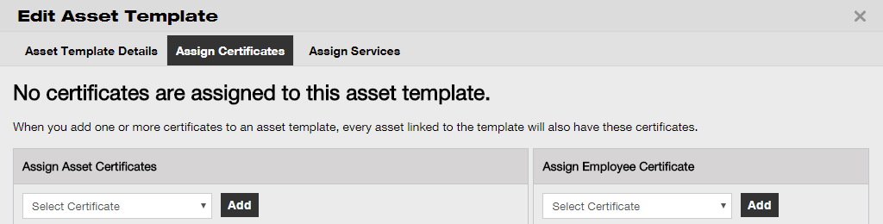

- Select and add certificates required to the template.

Note: In order to add certificates on this screen, they must have been previously added to ON!Track; you can add certificates on the certificates tab under main navigation point templates.

- Click on save and next at bottom of the editing screen to proceed the data entry on the assign services tab.

- Select and add Services required to the template.

Note: In order to add services on this screen, they must have been previously added to ON!Track; you can add services on the services tab under main navigation point templates.
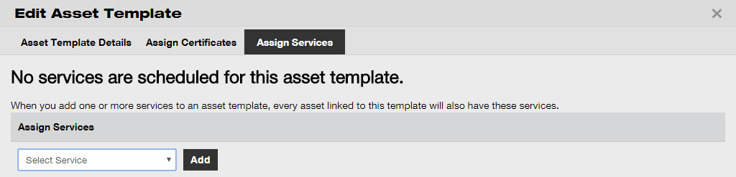

- Click on save and exit at bottom of the data entry screen to complete the addition of a new template.

ON!Track in general
The following questions clarify how to navigate, search as well as filter, sort, and customize tables in ON!Track.

How to navigate?
- Click the respective main-navigation points, i.e. dashboard, location, assets, employees, templates, and reports to see the information wanted; selected main-navigation points are highlighted in red

- Click on respective navigation tabs, i.e. asset Details, managed as, certificates, and services or click on save and next at bottom of a selection screen to navigate to the next tab to see information wanted; selected tabs are highlighted black.
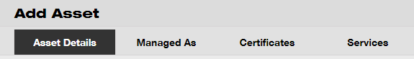

- Click on the big plus icon in the sub-navigation bar to expand the navigation structure below or click on the small plus icon to expand the navigation structure per parent location to see the contents.

- Click on respective action icons, e.g. add, edit, and delete to trigger wanted actions.

Note: Action icons may or may not come with a label, which names the according action; grayed-out action icons indicate that they are not active, often you need to select an asset, location, or empoloyee to activate the respective action icon.

- Click on yes or no confirm or cancel an action, e.g. deletion of a location.

Attention: Once deleted, data cannot be restored!

How to search?
Note: Although there are various places where to search any kind of information, here, it is shown how to use the search function in general.

- Click into the search field on a view where you would like to search for information, e.g. location tab in the main-navigation bar to search for an asset.

- Type in the search field what you want to search; while typing, matching search results (marked red) will be shown instantly.

Note: Information, which does not match with the search term, is blinded out automatically; to see all information (e.g. all assets in the list), delete the search term from the search field by clicking on the x-icon on the right-hand side of the search field.
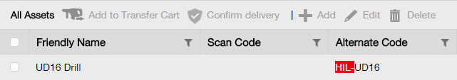

How to filter tables?
- Click on the funnel icon; a small screen with criteria by which you can filter opens after clicking.
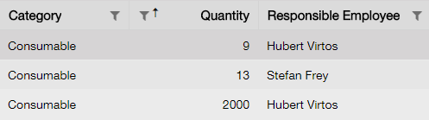

- Tick the respective checkboxes to indicate the filter criteria; the column only shows information based on the filtering.

Note: Active filtering is indicated by a bigger black funnel icon.
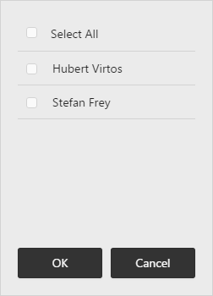

How to sort tables?
- Click on column header, to sort the contents of respective column in ascending order (arrow pointing upwards).
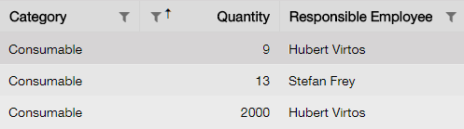

- Click on column header once again, to sort the contents of respective column in descending order (arrow pointing downwards).
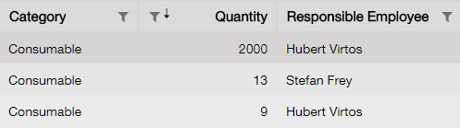

How to customize tables?
- Click on the double-arrow icon to add or remove columns in a table; a small screen with all available columns opens after clicking.
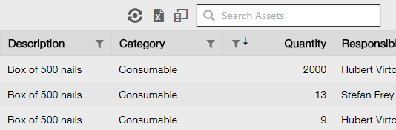

- Drag & drop columns from the table into the small screen - or vice versa: drag & drop columns from the small screen into the table.

Note: While you drag a column, a vertical gray line is shown which indicates where the column will be positioned in the table.
